

Executive Summary

Problem

After extended periods of time, high heel shoes cause stress on the wearer's feet leading to pain and discomfort. In an unpublished survey conducted by Duality in Fall of 2017 (n=134), it was found that heel discomfort became prevalent between 1-3 hours for 49% of respondents even though the events they were attending lasted 5 hours on average. Prolonged heel wear can lead to both long-term and short-term medical conditions including osteoarthritis, Morton's neuroma, and hammer toes[1]. Current methods for reducing high heel foot stress including: toe taping and use of gel inserts. Unfortunately, neither of these methods lessen the main cause of this stress: forefront foot pressure.

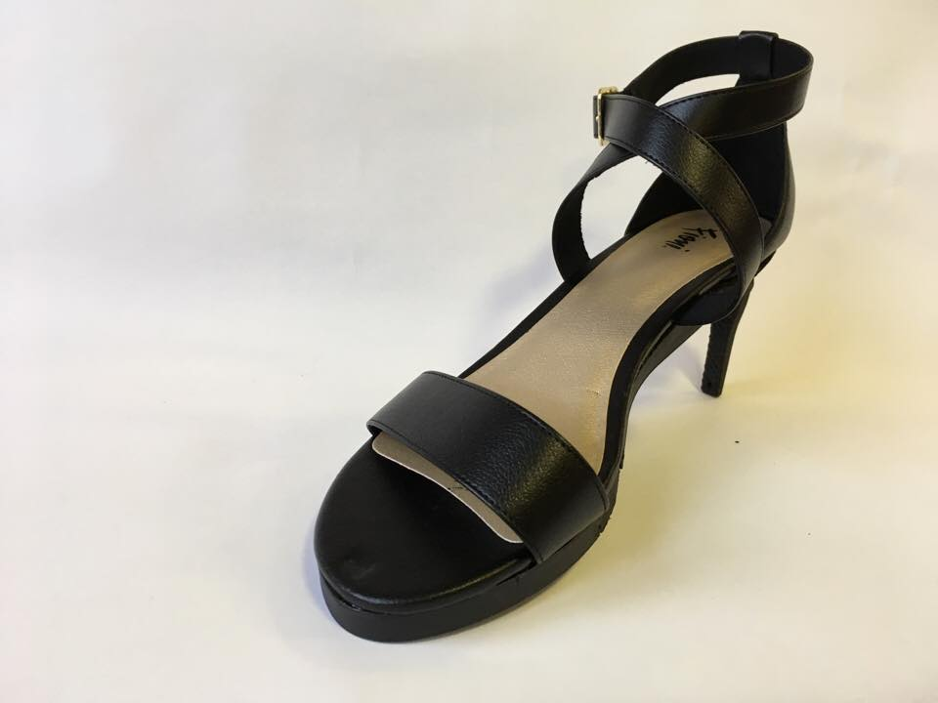Solution

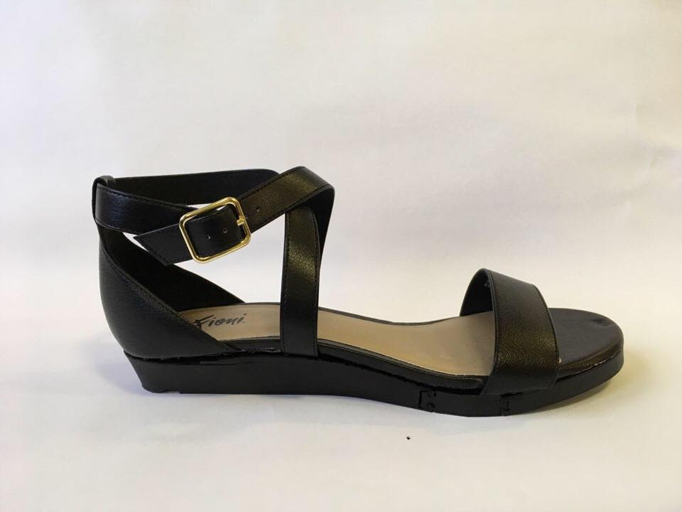Duality’s solution is a convertible shoe that will relieve the wearer’s discomfort by transitioning to a flat state while still giving wearers the option of an elevated state. This method allows for a balance between fashion and comfort. Through market research, Duality discovered that current convertible heels are economically unsuccessful due to high product costs and unconventionality. These claims from the market research were supported by the previously mentioned survey conducted by Duality: women want an affordable, fashionable, and convenient choice. Current competitors on the market use detachable heels making the shoes inconvenient to the wearer. Duality was inspired to create an option for women where no extra parts are needed. Duality's convertible shoe has a fixed heel that folds up into the sole of the shoe when wearers want to switch states. A flexible material is also used at the front arch to account for the foot's change in angle during the different states. Duality has currently developed a 3-D printed prototype and is working to refine the design to create a wearable alternative.

**Figure 1.** Duality’s 3-D printed prototype, proving design viability.

Marketability

In 2017, the global footwear industry annual revenue was $52,175,000,000 and the annual US consumer footwear spending was $29,750,000,000[2]. Women’s shoe sales made up 40% of this revenue. Women are the biggest consumers of apparel and footwear. The average woman purchases 5 new pairs of shoes per year. In recent years, the popularity of heels has declined while the popularity of trainers has increased[3]. This is because high heels are uncomfortable for prolonged periods of wear and women are tending to value their comfort over appearance. The use of a convertible high heel shoe mechanism would increase high heel sales while still meeting the market’s demand for comfortable footwear. 72% of women wear high heel shoes, with 39% of women wearing heels daily[4]. This gives Duality’s product the potential to reach the majority of the world’s largest consumers of footwear. Sales for footwear is expected to increase 25% by 2021[5]. Duality has the potential to operate as independent shoe company or license its convertible heel mechanism to already established shoe brands. Luxury shoes brands including Gucci and Jimmy Choo would be potential clients of Duality. In 2017 Gucci’s revenue was $7.6 billion with 19% coming from shoe sales[6]. That same year, Jimmy Choo’s revenue was $500 million[7]. Duality has the ability to bridge the gap between comfort and style, increase heel marketability for existing brands, and enter a billion dollar market.

1. American Osteopathic Association
2. <https://www.statisticbrain.com/footwear-industry-statistics/>
3. <http://www.minte)l.com/press-centre/fashion/high-heels-take-a-tumble-more-women-buy-trainers-than-high-heels-for-the-first-time-in-2016>
4. American Podiatric Medical Association
5. <http://www.minte)l.com/press-centre/fashion/high-heels-take-a-tumble-more-women-buy-trainers-than-high-heels-for-the-first-time-in-2016>
6. https://www.statista.com/statistics/267731/global-revenue-share-of-gucci-by-product-category/
7. http://www.annualreports.com/HostedData/AnnualReports/PDF/LSE_CHOO_2016.pdf